
Step-by-Step Google Map integration
- Code to be added to the script:
Data:
LOAD * INLINE [
Country,Population,GDP_PPP_M, latitude, longitude
Albania, 3600523, 19621, 41.153332, 20.168331
Algeria, 33858000, 269201, 28.033886, 1.659626
Argentina, 40301927, 523169, -38.416097, -63.616672
Armenia, 3230100, 17139, 40.069099, 45.038189
Australia, 21446187, 760800, -25.274398, 133.775136
Austria, 8340924, 317800, 47.516231, 14.550072
Azerbaijan, 8629900, 64082, 40.143105, 47.576927
Bahrain, 760168, 24245, 25.932619,50.568506
India, 200000, 24211,20.5937,78.9629
];

// Google Maps Key
// get a key here http://code.google.com/apis/maps/signup.html
// gmap_key = 'xx';
max_zoom_level = 17; //maximum value 17
// Variables required for calculating map
// No need to change these
var_pi180= '=pi()/180';
var_lat_offset= '0';
var_mc2= '=256*pow(2,$(var_zoom))';
var_mc1= '=256*pow(2,($(var_zoom)-1))';
var_mid_lat= '=min(Latitude)+(1+var_lat_offset)*((max(Latitude)-min(Latitude))/2)';
var_mid_long= '=min(Longitude)+(max(Longitude)-min(Longitude))/2';
var_zoom= '=max(aggr(if(max( round(256*pow(2,(_zoom_level -1)))+( Longitude *((256*pow(2,_zoom_level ))/360)) )-min( round(256*pow(2,(_zoom_level -1)))+( Longitude *((256*pow(2,_zoom_level ))/360)) ) <map_size_x AND max((256*pow(2,(_zoom_level-1)))+((0.5*log((1+(sin((Latitude)*pi()/180)))/(1-(sin((Latitude)*pi()/180)))))*((-256*pow(2,_zoom_level))/(2*pi()))))-min((256*pow(2,(_zoom_level-1)))+((0.5*log((1+(sin((Latitude)*pi()/180)))/(1-(sin((Latitude)*pi()/180)))))*((-256*pow(2,_zoom_level))/(2*pi()))))<map_size_y,_zoom_level,1),_zoom_level))';
var_maptype= '=if(isnull(only(maptype)),fieldvalue( '&chr(39)&'maptype'&chr(39)&', 1 ),maptype)';
map_size_x= '640';
map_size_y= '400';
SET HidePrefix='_' ;
// Field required for calcualting best zoom level
_zoom_level:
Load RecNo( ) as _zoom_level autogenerate(max_zoom_level);
maptype:
LOAD * INLINE [
maptype
roadmap
mobile
satellite
terrain
hybrid
];
set hideprefix = 'maptype';

- Add and configure a scatter chart:
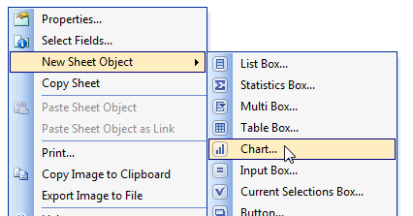
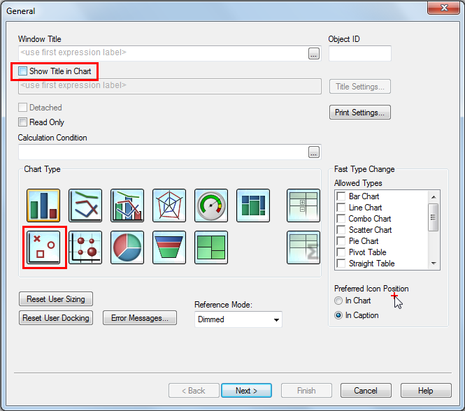

=> NEXT
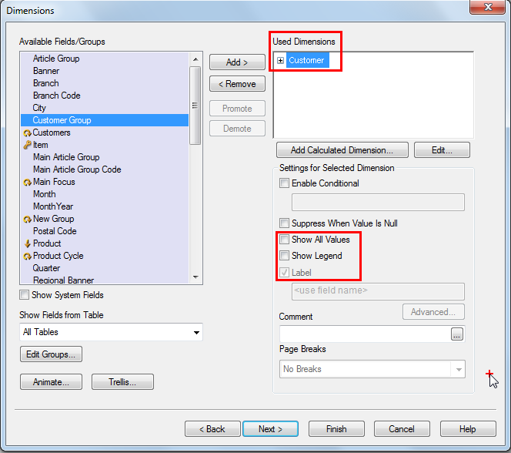
This defines the dots which will be plotted (Customers in that example).
=> NEXT

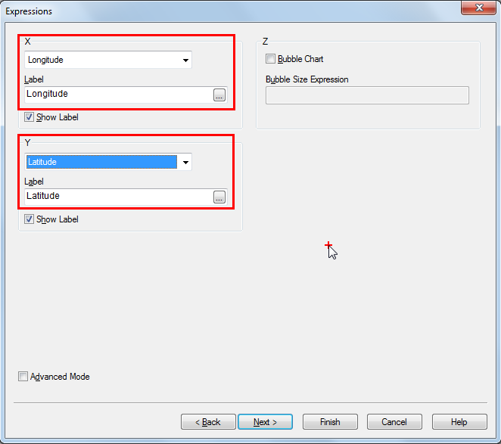
Click on Finish and exit the wizard.
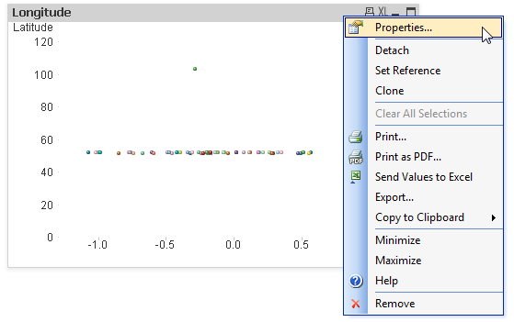
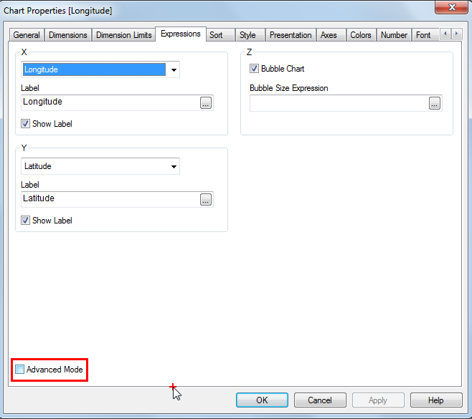
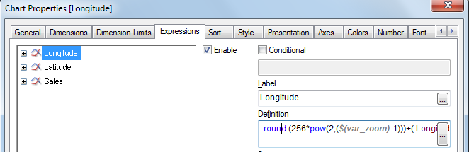
Longitude:
=sum( round (256*pow(2,($(var_zoom)-1)))+( Longitude *((256*pow(2,$(var_zoom)))/360)))
(or)
=avg( round (256*pow(2,($(var_zoom)-1)))+( Longitude *((256*pow(2,$(var_zoom)))/360)))

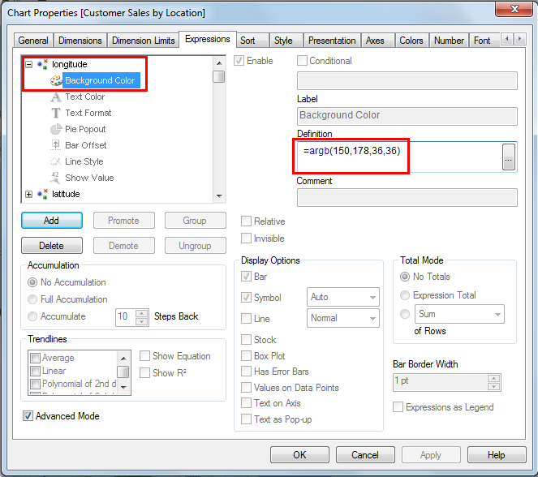
Background color:
=argb(150,178,36,36)

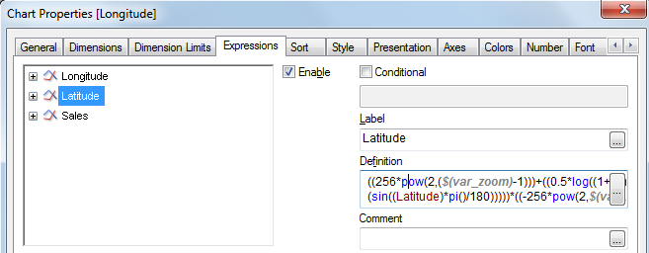
Latitude:
=sum(((256*pow(2,($(var_zoom)-1)))+((0.5*log((1+(sin((Latitude)*pi()/180)))/(1-(sin((Latitude)*pi()/180)))))*((-256*pow(2,$(var_zoom)))/(2*pi())))))
(or)
=avg(((256*pow(2,($(var_zoom)-1)))+((0.5*log((1+(sin((Latitude)*pi()/180)))/(1-(sin((Latitude)*pi()/180)))))*((-256*pow(2,$(var_zoom)))/(2*pi())))))

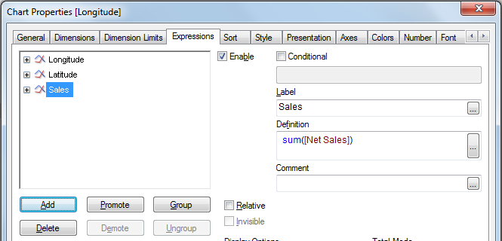
That value can be anything; it will control the size of the dots (Net Sales in that example).
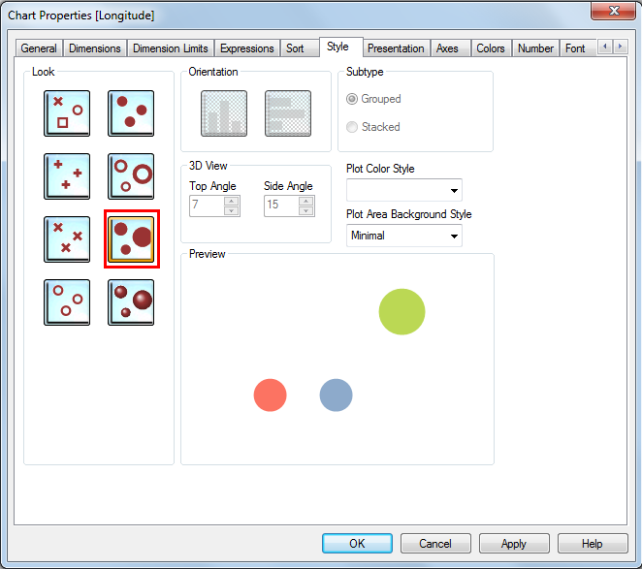

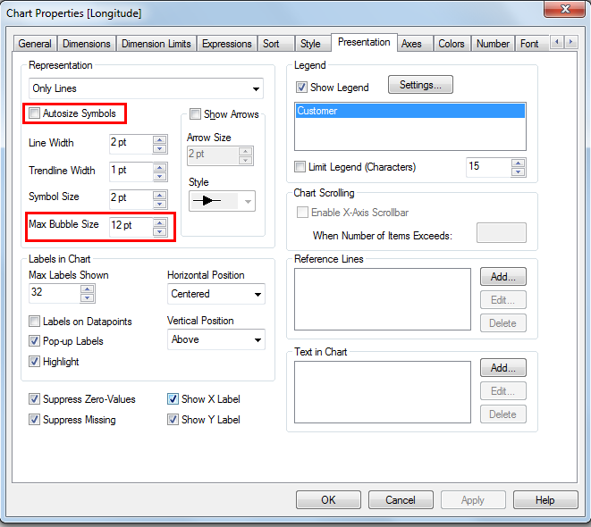
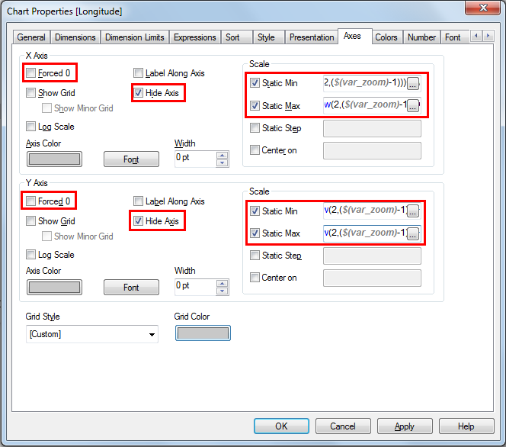
X axis:
Static Min:
=(256*pow(2,($(var_zoom)-1)))+( var_mid_long *((256*pow(2,$(var_zoom)))/360)) -round(map_size_x/2)
Static Max:
=( (256*pow(2,($(var_zoom)-1)))+( var_mid_long *((256*pow(2,$(var_zoom)))/360)) + round(map_size_x/2))

Y axis:
Static Min:
=((256*pow(2,($(var_zoom)-1)))+((0.5*log((1+(sin(var_mid_lat*pi()/180)))/(1-(sin(var_mid_lat*pi()/180)))))*((-256*pow(2,$(var_zoom)))/(2*pi())))+round(map_size_y/2))
Static Max:
=((256*pow(2,($(var_zoom)-1)))+((0.5*log((1+(sin(var_mid_lat*pi()/180)))/(1-(sin(var_mid_lat*pi()/180)))))*((-256*pow(2,$(var_zoom)))/(2*pi())))-round(map_size_y/2))

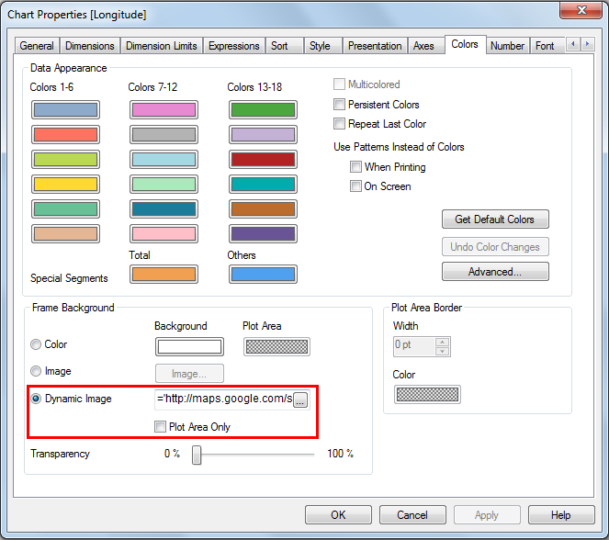
Dynamic Image:
='http://maps.googleapis.com/maps/api/staticmap?center='
&
num(var_mid_lat, '##############', '.', ',' )
&
','
&
num(var_mid_long, '##############', '.', ',' )
&
'&zoom=$(var_zoom)'
&
'&maptype='&var_maptype
&
'&size= '& map_size_x &'x'&map_size_y
&
'&sensor=false'

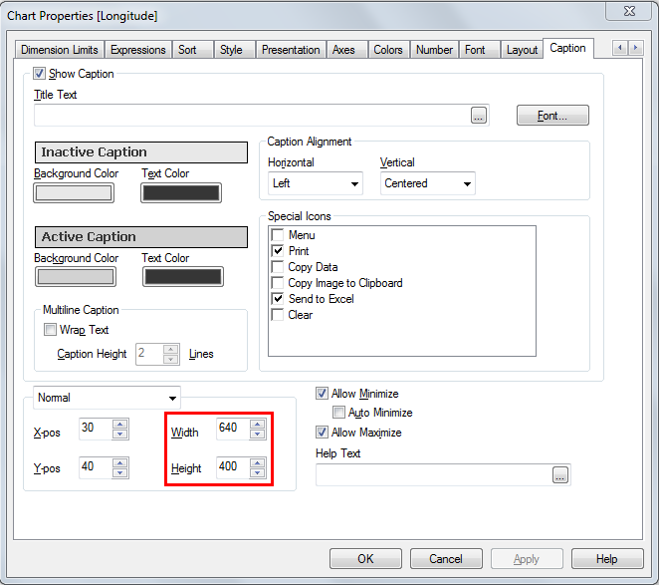
Size of the chart, according to map_size_x and map_size_y (defined in the script).

Result:
